User's Guide
I would like to present database “MusicMusicCollection”. It was created to help to organize home music collection. Data entry form lets User view, enter and edit data. Queries can be used to get specific information from a database. Reports let User display and print the data in tables or queries arranged exactly the way he (she) wants.
Database contains five tables: “Song”, “Album”, “Artist”, “Composer” and “Genre”. User can enter data of his (her) music collection into the tables.
As alternative for entering data User could use a data entry form
“Song Album Artist Composer Genre Data Entry Form”.
There are some steps to help to User:
1. Click on the Forms icon on the left side of the database window.
2. Open data entry form. ( pic.1)
3. Click on “New Record” on the Navigation Bar. (Pic.1)
4. Insert data in main form- Song. If you don't have information for some fields- live it blank. Press <Tab> till end of row and proceed till the first column of the next row.
5. Return to the row you just filled up. Now you can fill subforms (Artist, Album, Composer, Genre) up.
6. Don't press “New Record” on the Navigator Bar. Navigate pointer
(green triangle) on the second column of the first row one of subforms (“Album”, “Artist”, “Genre”, “Composer”). Fill the first row up, press <Tab>,
pointer has to be on the next row. Your record saved. Proceed to fill the rest of subforms up.
7. After filling all subforms return to main form (Song) and finish to fill the row (columns ArtistNameID, ComposerNameID, AlbumNameID, GenreID). You can take this ID-s from corresponding forms. Proceed with <Tab> till first column of the next row. Your record saved.
The data you enter or edit in your form will be stored in the tables on with the form is based.
If you need to delete wrong data click on this row ( green triangle will be in the first column of this row) and click “Delete Row” on the Navigation Bar. (Pic.1) If you will delete row from the main form (Song) all information in subforms will be deleted to.

Previous Record Last Record
List Box First Record Next Record New Record Delete Row
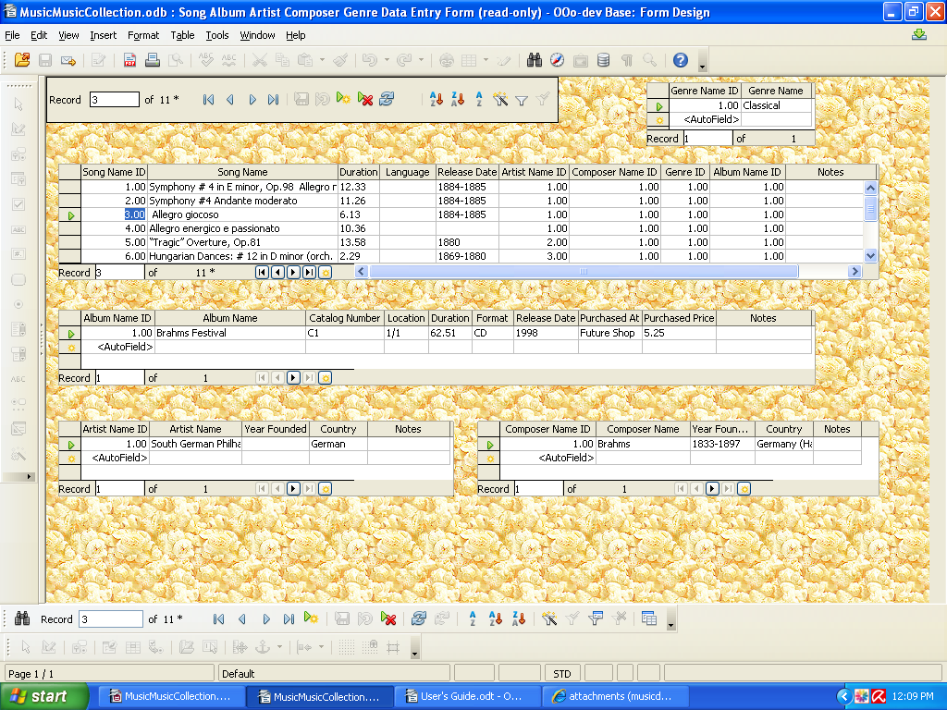
Pic.1
Find Record Delete Row Sort Descending
First Record Sort
Previous Record Sort Ascending
New Record
Next Record
Last Record

You can use data entry form as a view form. Navigate pointer (green triangle) on the record (row) in main form- “Song” and you will see all information related to this song in subforms. Or for this purpose you can select number of record in suitable field of List Box (pic.1).

Queries.

Click the Queries icon on the left side of the database window. For some
of them user needs to enter parameter in the text box “Value” of “Parameter Input” window. These queries also will help to user to check name of Artist, Composer, Genre he (she) wants to enter in “Artist”, “Composer”, Genre” subforms. Are they already exist or no.
There are five Parameter Queries:
“Query Find Album”
“Query Find Artist”
“Query Find Composer”
“Query Find Genre”
“Query Find Song by Location of Album”
And five Queries with no parameter input:
“Query List of Artists and Songs they Performed”
“Query List of Songs by Composer”
“Query List of Songs by Location”
“Query Locations of Albums”
“Query Song Album Artist Composer Genre” created to display list of songs
by artist, composer, album and genre. List of songs sorted in ascending order on the Song Name field.

Reports.
Click the Report icon on the left side of the database window.
There are five reports. They are similar to Queries.
“Report List of Artists and Songs they Performed”
“Report List of Songs by Composer”
“Report List of Songs by Location”
“Report Locations of Albums”
“Report Song Album Artist Composer Genre”

